# **Understanding the Problem**

|  |  |
| --- | --- |
| Team Members: | * Jonathan Argumedo * Cristian Molina * Bryan Molina * Diego Rivera * Will Palafox |
| What is the problem? | A program director, who is also part of the CS graduate committee, is inundated with the responsibilities of managing the MSSwE AMS program (i.e., Master of Science in Software Engineering Advising Management System), which requires a high level of tedious manual tasks, creating opportunity for human error, when they could potentially be automated. |
| Why is it important? | It is important because an automated system would both improve service for the students and reduce the time the faculty and staff require to manage the program; it would also help reduce errors in multiple areas of the process since there are multiple systems, which are not interconnected.  The system will automate most of the repetitive tasks done by the program director by, for example, handling the validation of forms submitted by the students, allow students to schedule advising meetings when all the advising forms are complete, or providing a high-level view of the student academic history to speed up the advising process by providing all the relevant information to the program manager in one click. |
| What has been done before to solve it? | The program director provided several standard electronic forms in Excel that they currently use to try to share the information required for the process. The program director and students have also performed numerous manual tasks (e.g. checking available courses each semester, adding course grades, checking course prerequisites, etc.) (Class Project MSSwE advising Spring 2021, page 2). |
| What is your project / system to be developed / System of Interest (SOI)? | Develop a system that decreases the amount of work done by the program director by automating or reducing repetitive tasks required by the manual processes currently used to advise students. |
| Why is your project important?  (What percentage of the stated problem is solved?) | This project if implemented correctly, will help the program director save time, but at the same time it will provide better service for the students. The students, or stakeholders, should see an increase in speed and quality of service from the Program Director. |
| What is the scope to be developed during this project (semester)?  (If the system is complex, indicate if you are building the whole system, subsystem, module or component?) | Our team will analyze and specify the system requirements, which will solve the various problems and be qualified by measurable conditions. (IEE 29148 Std. Requirements Engineering, 5.2.4). and propose a design for the system implementation based on those requirements. |
| What documentation will be generated?  (Only consider artifacts for the requirement engineering activities done during the concept stage. | Our team will create a Software Requirements Specification for the system with the help of the customer and the conceptual design of the system which will include system design document which will contain system dependencies, module breakdown, interface definitions and a development plan/schedule. |

# Context Diagram Level 0

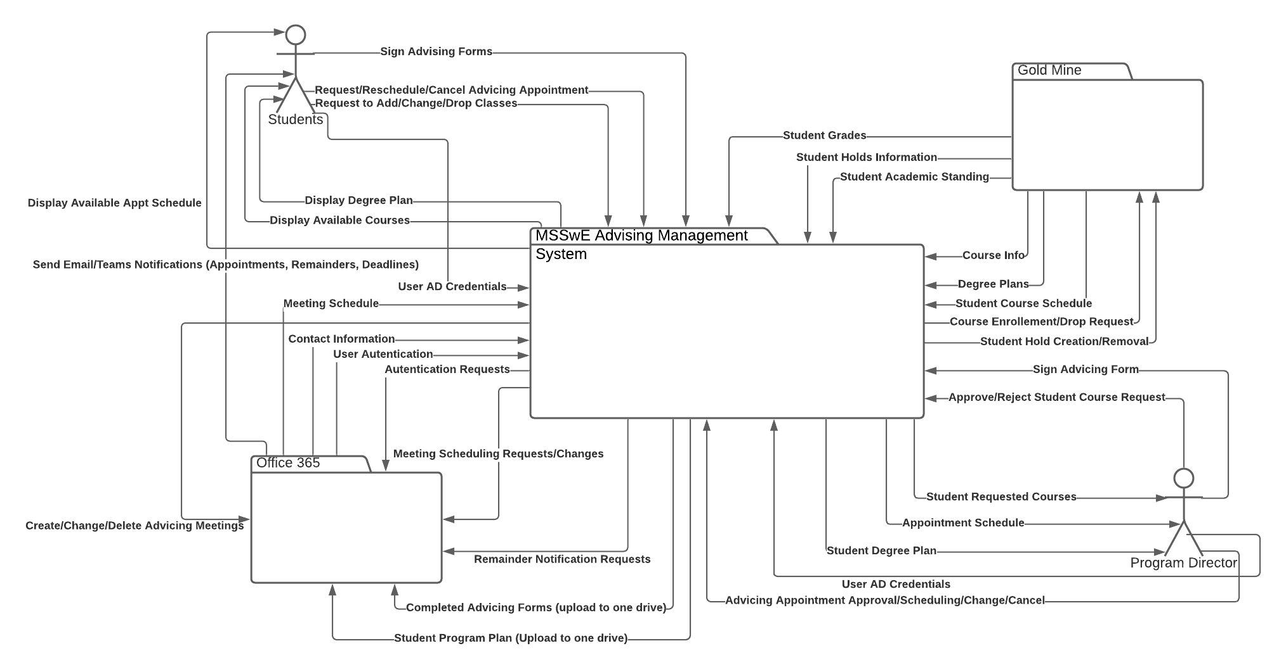

Lucid Chart Link: <https://lucid.app/lucidchart/invitations/accept/87331683-429f-47dc-95c2-ff6f3d605f9e>

# Problem Vs System Scope Diagram

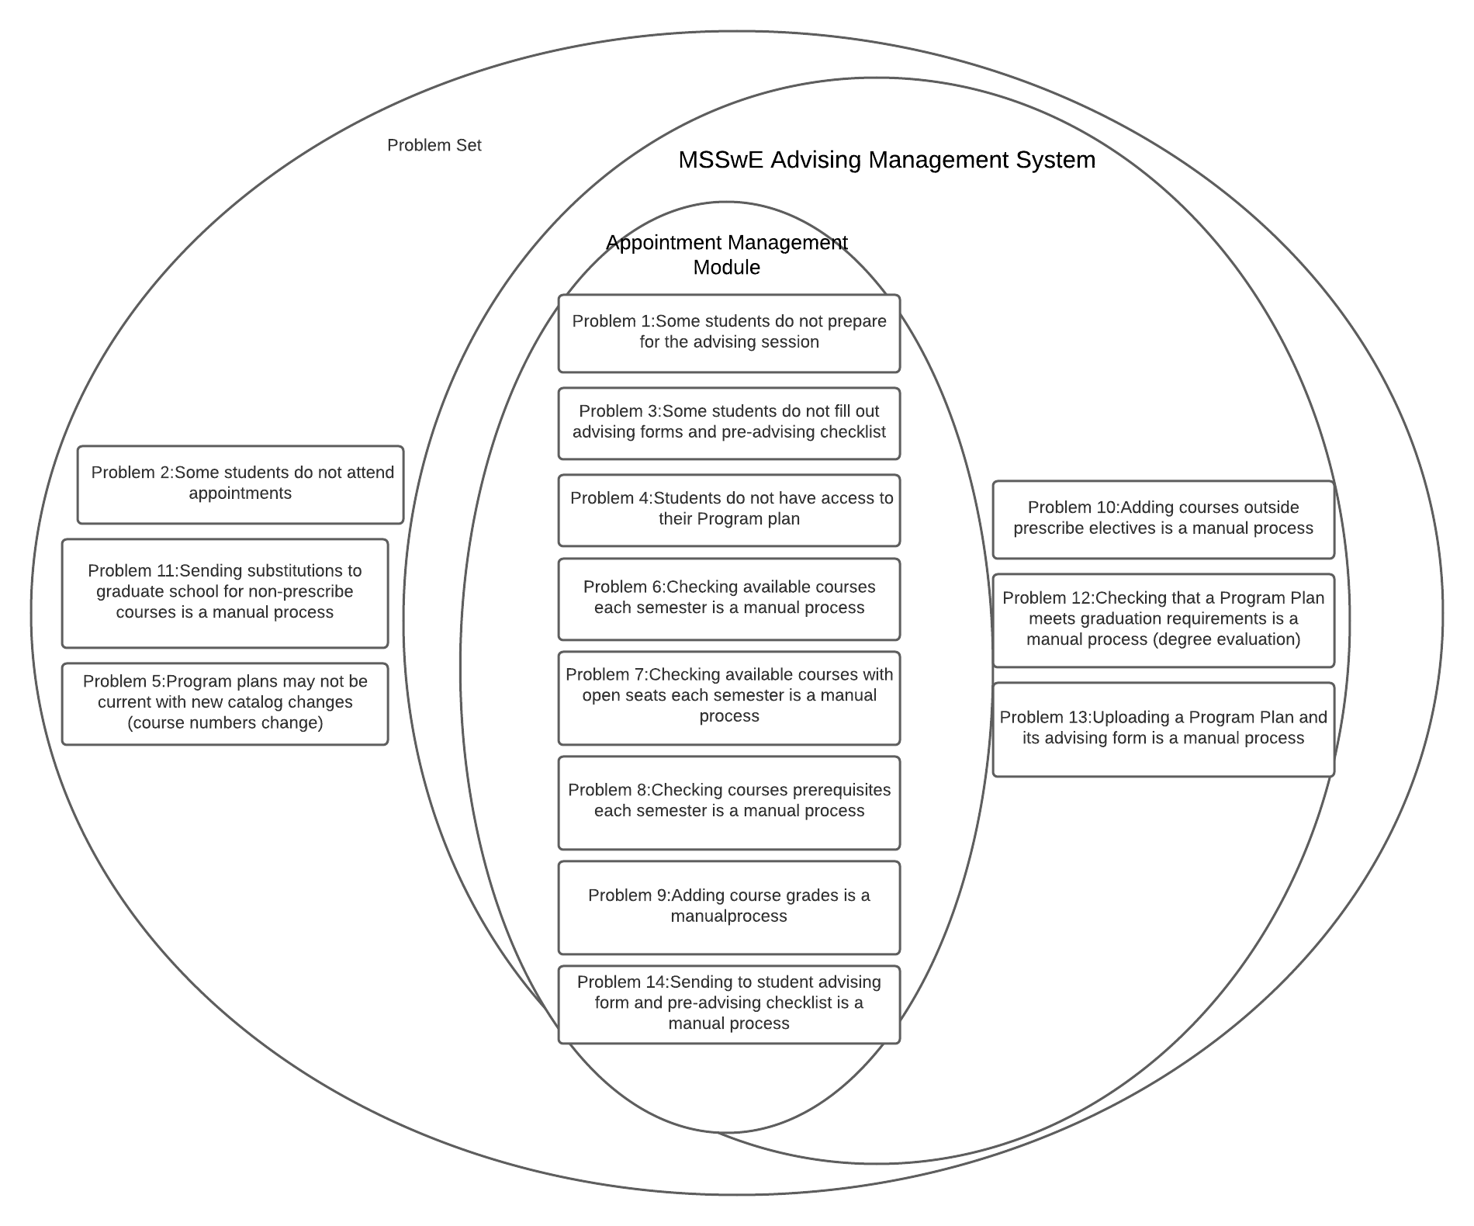

Lucid Chart Link: <https://lucid.app/lucidchart/invitations/accept/87331683-429f-47dc-95c2-ff6f3d605f9e>

# System Acceptance Criteria

For the system to be accepted it shall fulfill all Problem/areas of opportunity referenced in MSSwE AMS document and the stakeholder shall approve it.